Test_20 10 2022

Task1)

SELECT [ProductSubcategoryID]

FROM [Production].[Product]

WHERE [Weight] > 150

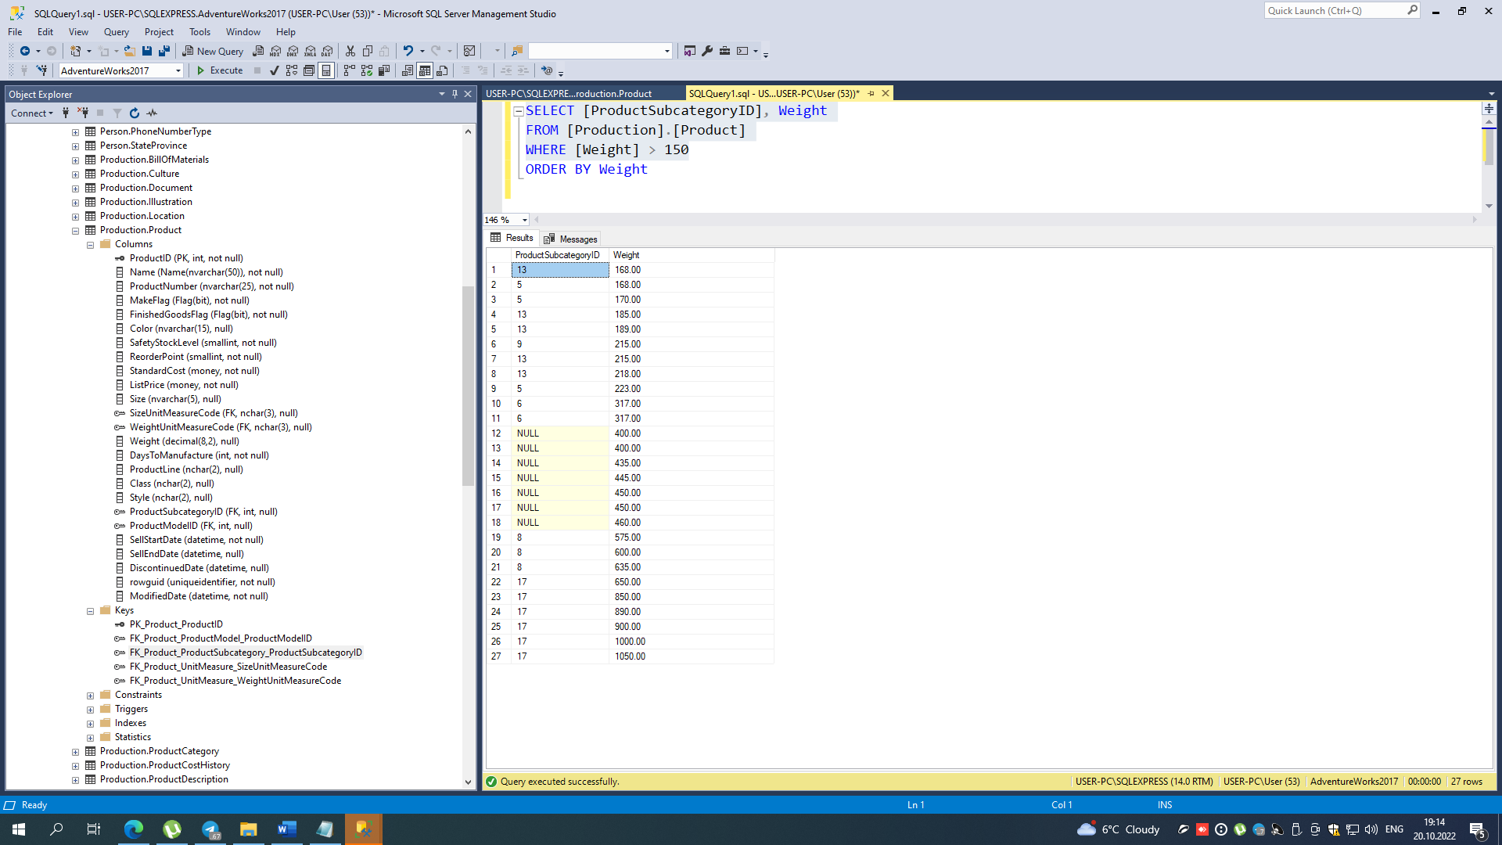

Task2)

V-1

SELECT Name, StandardCost

FROM Production.Product

WHERE StandardCost = (SELECT MAX(StandardCost) FROM [Production].[Product])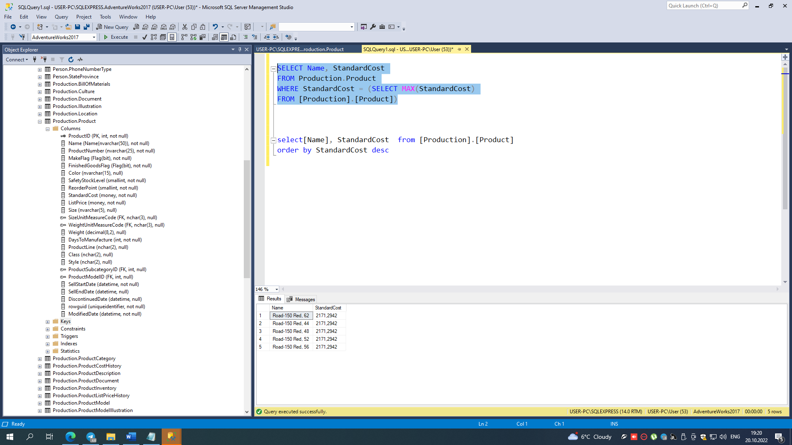

v-2

SELECT TOP 1 WITH TIES Name, StandardCost

FROM [Production].[Product]

ORDER BY StandardCost DESC

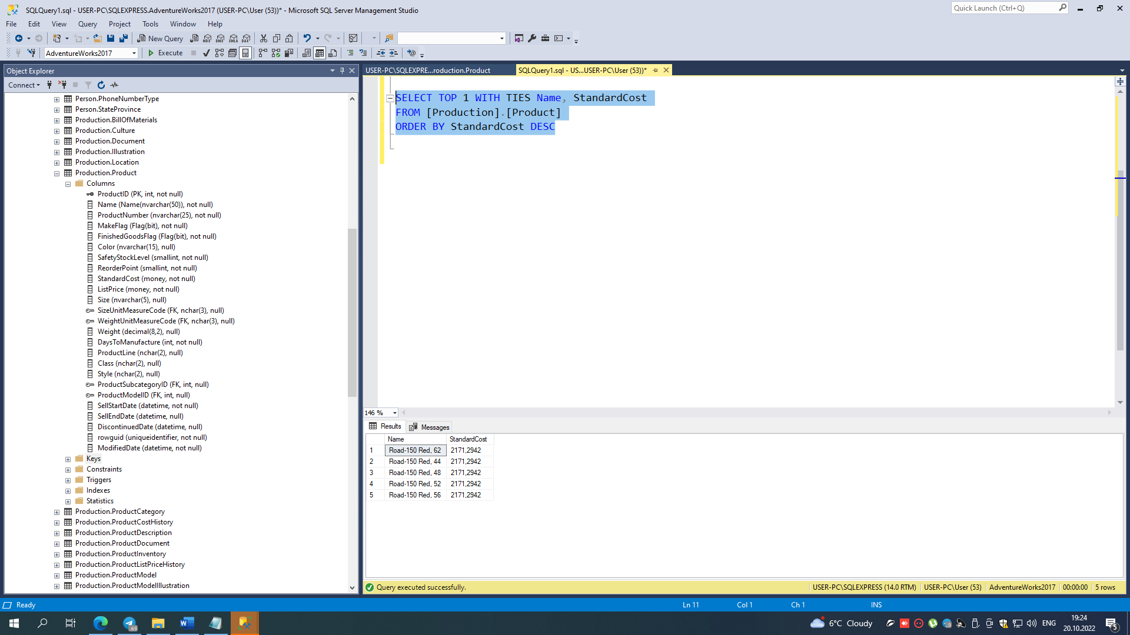

v-3

SELECT Name, max_cost

FROM

(

SELECT Name, MAX(StandardCost) AS max_cost, RANK() OVER(ORDER BY MAX(StandardCost) DESC) AS rnk

FROM Production.Product

GROUP BY Name

) t

WHERE rnk = 1

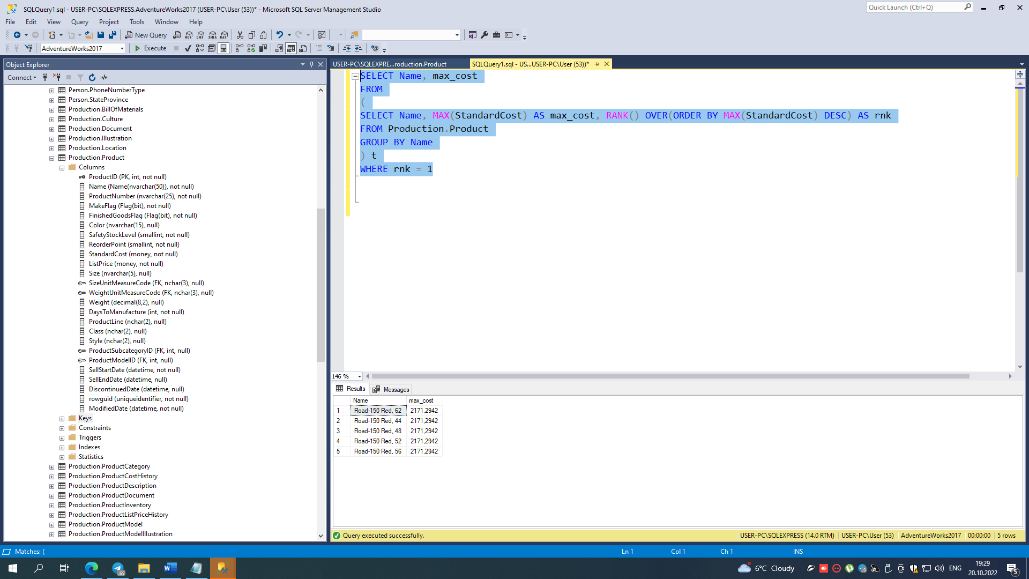

v-4

SELECT Name, StandardCost

FROM

(

SELECT Name, StandardCost, MAX(StandardCost) OVER() AS rnk

FROM Production.Product

) t

WHERE rnk = StandardCost

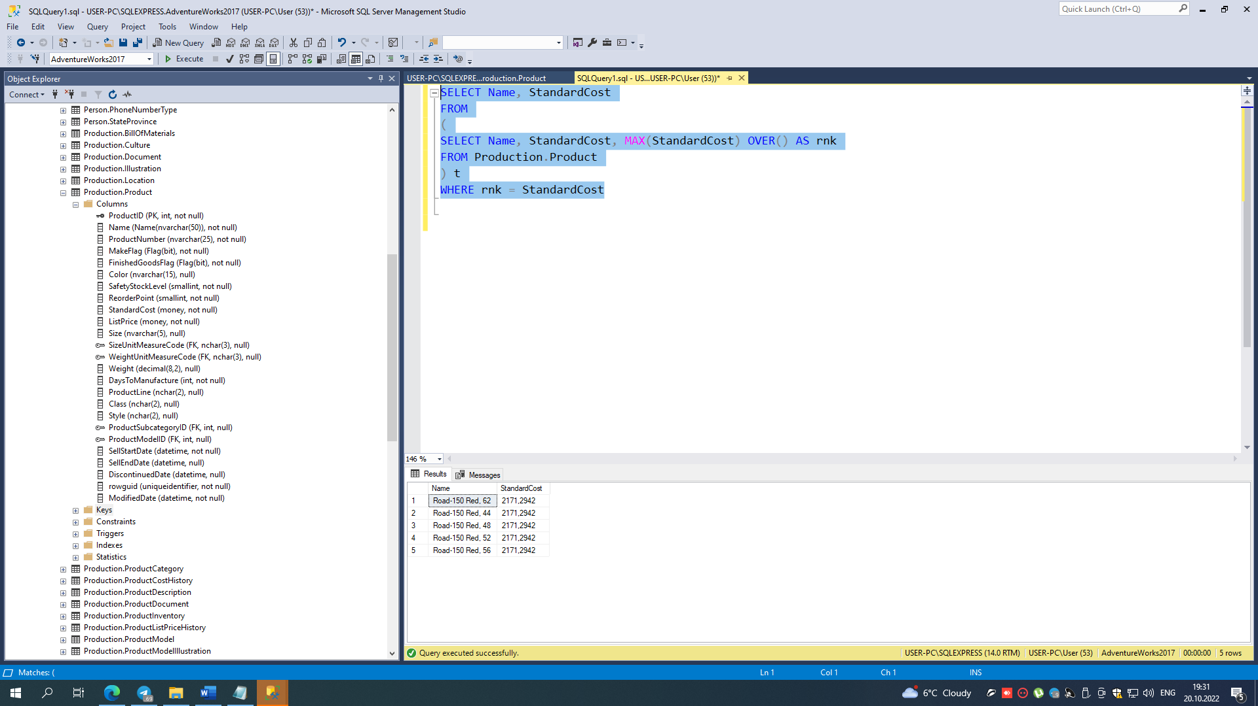

Task3)

SELECT id_Store, Name

FROM Store_dim

EXCEPT

SELECT DISTINCT id_Store, Name

FROM Sale_fct sal JOIN Store_dim s on sal.id_Store = S.id_Store

where OrderDate > DATEADD(YEAR, -1, GETDATE())

Task4)

SELECT Name, Last_Name, COUNT(s.SaleID)

FROM Seller_dim sel LEFT JOIN

(SELECT Date, SellerID, SaleID FROM Sales_fct s WHERE Date > DATEADD(YEAR, -15, GETDATE()))

ON sel.SellerID = s.SellerID

GROUP BY Name, Last_Name

Task5)

SELECT category, user_id

FROM (SELECT category, user_id, COUNT(is_read) as cnt FROM Notifications WHERE is_read = TRUE GROUP BY category, user_id) n

LEFT JOIN

(SELECT id, email FROM Users u WHERE email = 'alex@gmail.com' ) s

ON n.user_id = s.id

WHERE cnt > 50